CONTENTS
Spiritual Director Page 2
Prayer Requests Page 2
Chrysalis Pages 4-7
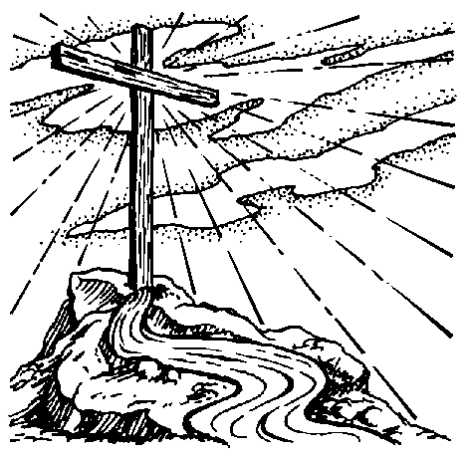
The Upper Room Emmaus
of the Greater Fredericksburg Area

September 1995

From the Lay Director . . .

Dear Sisters and Brothers:

How blessed we are by God . . . . a Chysalis just ending and two weekends to look forward to. It’s not too early to start that prayer and agape, for the November and December weekends will be here before you know it.

So servants of the Lord, prepare ye the way. Get your team and candidates’ applications in. If you don’t sponsor or team, think about a partial or full scholarship for someone.

I’ll miss you all in September, but Eva Werhle will keep the E-train on track. I have been asked at the gatherings about grouping. My concern is that we do the teaming and weekend highs and then fall victim to the 4th day valleys. Grouping can keep us out of the low spots and even be the highs with Christ. We sometimes need the help mid week or so. Even a good old Wednesday night Prayer and Praise can’t do what grouping can.

Grace and peace of Our Lord Jesus Christ be with you. DeColores!
Your brother in Christ - Butch Cover

The Next Fredericksburg Gathering

Where: | Summit Presbyterian
When: | 9/9/1995 at 6 p.m.
 | Fellowship at 6 p.m.*
 | Music begins - 7 p.m.
Devotions: | Carolyn Canady
Fourth Day Speaker: | Karen King
Child Care: | Kurt and Gina Edsall
Board meets at 4 p.m.

*Please bring drinks and refreshments to share.

Upcoming Gatherings

October 14th, 6 p.m., Rehoboth UMC
November 9th, 6 p.m., Rehoboth UMC

Upcoming Weekends

Fredericksburg Men #17 Nov. 2-5
Fredericksburg Women #18 Dec. 7-10

From the Spiritual Director . . .


To have a gift offered to you is a very joyful experience; to receive a gift with the intention of using or applying it to it’s full advantage is even more of a blessed thing.

When we entered into the body of Christ through faith in and of our Lord Jesus, God also placed us into an environment of instruction, training, nurturing and maturing. This environent consist not only of church body fellowship,but “one on one” education. How does God bring about this task? By surrounding each of us with apostles, prophets, evangelists, pastors and teachers. Ephesians 4:12 says that they have been laid before us (or perhaps we have been placed beside them?) so that we, the body of Christ, can be perfected (matured), and be able to “more successfully” fulfill and do the work of the ministry.

Isn’t it amazing when someone in the body has received a gift; a gift that God has honed and refined to some degree, and that person has a desire to help others grow and mature with who may have that same gift in their lives. But alas, because of pride, or envy, or jealousy, or fear or doubt, the teacher (or teaching) is rejected . . . .

The result: the one who received one talent (Matthew 25:14-30) still has but one talent to offer his Lord at his return.

The result: those who needed the benefit of the ministry suffer and go without.

The result: man ursurps his will over the will of God, thereby grieving or possibly quenching the Holy Spirit.
The result: growth, ability, insight see little or no maturity.

If we will learn to reach out and receive the blessing of God that He sends through our brothers and sisters, He will surely see to it that in our “growing” we will have something to pass on to others.

Love,

Sonny Thompson

PRAYER REQUESTS

Ken Erisman - who lost his home to a fire.

Kelly Seiden

The 3 new butterflies living with the Seiden family - Shannon, Kendra and Leslie

Chancellor Christian Church as they seek God’s will for the building of their new church. They are seeking prayer warriors to assist them in praying in church, at home in your individual prayers and in a prayer chain. For more information, call Mark Dunn or Anthony Lutchman at 703-898-0361.


A NOTE FROM ANGEL . . .

Hello and praise our Lord Jesus!

James 3 speaks to us concerning the tongue, and the power thereof. A few months ago, because of words spoken to me, I almost destroyed myself. Now, I sit here sharing the importance of knowing how powerful your tongue is.

Through this Emmaus community, we come to meet many brothers and sisters, and for a weekend, we are overwhelmed with the love of Jesus. Then, when everything quiets dow, what happens to the people? Do we keep in touch? Well, I have just been in a mode of no one is ever going to hurt me again. But with a little help, I am learning that I am okay and I can go forward with my life, but in my learning I have found out just how many others are out there crying out for love, wondering why the high of the weekend is no longer there. The depression is widespread and Jesus is asking: where is my body? I want to challenge you to be doers and not hearers only of God’s Word. When someone comes to mind, pray for them, give them a call, send them a note . . . you’ll never know the life you may be saving andthe body you may be building. I want to thank everyone who sent their support and love the weekk after I got out of the hospital. It was very healing. I also want to remind you to do unto others as you would like them to do unto you. I’m not saying for you to do it to get it in return, but do it because someone else needs it and it would be what you would like done to you. I’d also liek to end with these words sent to me on a card today. It could be from anybody, but it was from somebody who needed a friend:

The other day I felt like a puppy at a pet store - admired by all, but cared for by none.
I wanted so much for someone to hold me and spend time playing with me. And then you stopped and sat down with me, (and wrote) even though you were far too busy to do so.
Thanks for taking time to love and care
for me.

Take time to reach out and touch!

With love forever in Jesus,

Angel Fulkerson



LOOKING FOR GROUPING PARTNERS

Joe LaPlata
Richard Warner
Cheryl Ramsey 804-448-1853
Anthony Lutchman 703-898-0361

FREDERICKSBURG EMMAUS
BOARD OF DIRECTORS

Cover, Butch - Lay Director
Wehrle, Eva - Assistant Lay Director
King, Karen - Secretary
Thompson, Betty Gray - Treasurer
Thompson, Sonny - Spiritual Director

Branton, G.C. Koy, Ken
Buttram, Debbie Rice, Judy
Cianelli, Gino Shortridge, George
Crabill, Pat Warner, Richard
Dunn, Mark

