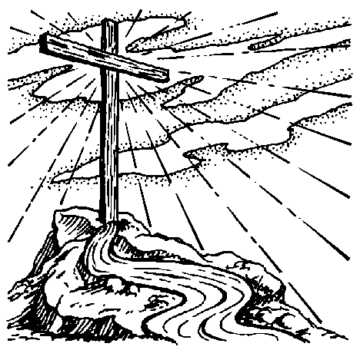
The Upper Room Emmaus
of the Greater Fredericksburg Area

JULY 1995

From the Lay Director:

It is an honor and a privilege to be chosen to be your Lay Director. I look to the Holy Spirit and your prayers as a community for wisdom and guidance this coming year. I view the Emmaus community as a picture of the bride of Christ. We are all denominations together. This community, as the bride of Christ, is continuously bringing together more and more churches into reconciliation. I feel this is what the Lord has called me to do this year. The prayer I ask from the community is to suggest churches and pastors that I might contact who would be interested in coming into the Emmaus community. As a community, we can address racial, denominational and cultural diversity and become one in Christ.

Thank you for your prayers - please continue all year long!

In Christ’s love -

Butch Cover

Dear Fredericksburg Emmaus Community,

I want to thank you for your support over the past year and for the joy that I have had and received in serving you as Community Spiritual Director. This has been a growing and enriching experience for me. I’m being following by a very capable and excellent spiritual leader, Sonny Thompson. I hope you will give him the same support and encouragement you gave me. Also, continually lift him up in your prayers as he seeks to discharge the duties of his ministry.

Since I have come into this community, I have seen a lot of growth and ministry take place and I just praise God for it. When we seek to honor God, and Him only, the results are so satisfying. Of course, I will still be involved in the community, and I have another year to serve on the board. I’m looking forward to what God is going to be doing in the next several months. Just keep this ministry in your prayers and diligently seek God for what your part is in this community. I love all of you, and may God continue to richly bless you in all good things.

Continually growing in Him,
Mark Dunn

From the Spiritual Director . . .


Can you believe it? In a matter of minutes, 365 days have
passed by, or should I say blown by since the last Emmaus board
election. Once again, with a slight flip of the wrist, another page
is turned in the saga of the Fredericksburg Emmaus community.

I am looking forward to see how our Lord Jesus wants to continue the unfolding of His plans and purposes for the next 365 days. The new board would greatly desire and appreciate your prayers for direction, sensitivity, and submission to the Holy Spirit.

Please remember, the effectual, fervent prayers of a righteous man has an incredible impact! (Speak words of life over your community.)

Now before time slips away, I would like to offer us all a “new year” challenge - and it is found in Romans 8:14 . . . “For as many as are led by the Spirit, they are the sons of God.” Well, if this is the case, we may ask, “Holy Spirit, where will thou leadest me?” He will most assuredly reply (Psalms 25:10) “All the paths of the Lord are mercy and truth unto such as keep His covenant and His testimonies.”

Before I can claim to be spirit filled, I must look to see how and where I am walking in my life. Psalm 119:105 declares that God’s word is the lamp that lights the way in which we should walk. If we walk in the light as he is in the light, we will have fellowship, one with another and the blood of Jesus Christ, his son cleanseth us from all sin. Let us allow our steps to be ordered of the Lord and start enjoying true Christ based partnership

In Christ’s service -

Sonny Thompson


NEXT FREDERICKSBURG
GATHERING:

July 8th, 6:00pm | Tabernacle UMC
UPCOMING GATHERINGS:
August 12th, 6:00pm | TBA
UPCOMING WEEKENDS:  Fredericksburg Chrysalis #3  Fredericksburg Men #17  Fredericksburg Women #18 | August 3-6  November 2-5  December 7-10

PRAYER REQUESTS -

For Mary Glissen, Fredericksburg #8, who will have surgery on July 10th. Some get-well agape can be sent to: Mary Glissen
c/o Space #16
816 Alsace
Castroville, TX 78009-2990

For Catherine Hudgins as she undergoes treatment for cancer.

For the Miletic family, who recently arrived in Fredericksburg from Bosnia. Osman, the father is suffering from cancer and needs heart surgery. Amira, the mother; Essa, their 19 year old daughter; and Vedran, their 13 year old son are in need of your prayers as they adjust to life in a new country and deal with their father’s illness.

